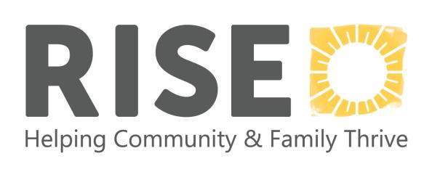

RISE
2120 Fordem Avenue, Madison, WI 53704
Phone: 608-250-6634
Fax: 608-250-6637

Welcome Baby & Beyond Referral Form

Date: _________________________

Primary Parent/Caregiver:

Name: Date of Birth: Street Address: City: Zip: Phone: Email: Alternate phone and contact name/relationship:

Other Parent/Caregiver Involved with Child:
Name: Date of Birth: Phone: Relationship to child:

Children:
First name | Last Name | Date of birth | Gender  er
1. |  |  | M | F
2. |  |  | M | F
3. |  |  | M | F
4. |  |  | M | F
Currently pregnant?  Yes No |  | Due date:

**Please use back to list any additional children

Referral Source:

Name: Agency: Phone: Relationship to family: Do you have a release of information for RISE on file? Yes No

Other agencies involved with family:

Reason for Referral: (Please be as specific as possible)

Please include any other information you think would be helpful for us to know:

Are you enrolled in any other programs at RISE? Yes_____ No_____

Are you interested in any other programs at RISE? Yes_____ No _____

Can we share your information with other programs at RISE? Yes_____ No _____

Please return this form to : RISE, Attn: Welcome Baby & Beyond

- By Email: info@risewisconsin.org

- By Fax: 608-250-6637

