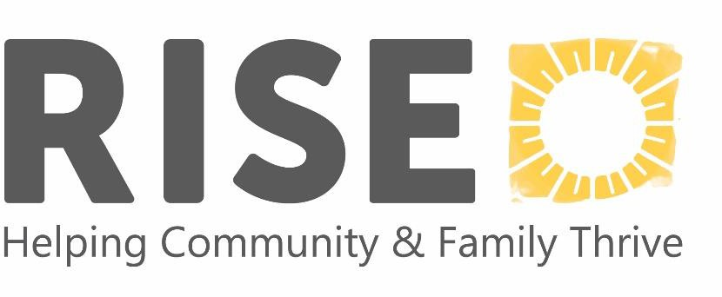Program Wish Lists

RISE’s Wish List is separated out by our specific program needs.   
We gladly accept new or new-like items.

**Please note:** RISE cannot accept the following items due to capacity or liability reasons: used clothing, stuffed animals, car seats and cribs (unless brand new and still in packaging), items in poor condition, furniture, or electronics   
(TVs, computers, etc.) If in doubt, please contact us!

**The following items would help support local children, families and individuals.**

* Winter coats (boys and girls toddler sizes)
* Hats/gloves/winter apparel
* Shoes/boots (all kids’ sizes)
* Clothes for boys and girls (sizes: newborn to 14-year-olds)
* Costumes/dress-up clothes
* Diapers (sizes 4, 5, & 6)
* Pull-ups
* Baby wipes
* Changing pads
* Baby formula
* NEW underwear (preschool to teens)
* Bus passes
* Gas cards

# Items needed across RISE programs

* + NEW socks (preschool to teens)
  + Pajamas (sizes 10-16)
  + Gym shorts for children
  + Pack n’ Plays
  + Gas cards
  + Gift cards to grocery stores
  + Gift cards for parents (can be any denomination)
  + Toiletries (large sizes of shampoo, conditioner, body wash, etc.)
  + Safety/babyproofing supplies (baby gates, door locks, door alarms, outlet covers, cabinet latches etc.)
* Art supplies/kits
* Non-toxic tempera paint
* Crayola watercolors
* Books (can be new or used if in good condition. Also, in English and/or Spanish)
* Basketballs
* Bath/water toys
* Current Disney/Pixar movies and cartoons
* LEGO kits (small)
* Backpacks
* Alarm clocks
* Boppy pillows
* Personal first aid kits
* Batteries (AA or AAA)
* Calendars (wall hanging)

# Early Childhood Programs Specific Items

* + Cleaning supplies (disinfectant wipes, etc.)
  + Laundry detergent & Infant laundry soap
  + Haircare for all types of hair
  + New gender-neutral backpacks (for children going to 4K)
  + 2T-5T clothes, including socks and underwear
  + Diaper Rash Creams (Vaseline, Aquaphor, Desitin)
  + Art supplies (especially Crayola Colors of the World crayons)
  + Gift cards for families (Walmart preferred)
  + Transportation assistance for families (Kwik Trip gift cards, cab vouchers, or bus passes)
  + Feminine hygiene products
  + Sippy Cups, Toddler Dishes & Utensils
  + Jump Ropes
  + Nightlights
  + Tempera Paint Sticks
  + Sleds that can be pulled
  + Kids’ Shovels
  + Frisbee Golf Discs
  + Weighted Vest
  + Weighted Blanket
  + Dramatic Play toys/games for outside

# Respite Specific Items

* Clothing sizes 6+ (leggings, shorts, sweatpants)
* Visual Timers
* Scented Markers
* Skateboards / Balance Boards
* Microsoft Store Gift Cards (for Xbox games)
* Costumes (Unicorns & Mario Bros)
* Pajamas/Character Onesies
* Gas cards

# Mental Health Programs Specific Items

* + Lockboxes (various sizes)
  + Calendars (wall, purse or other sizes)
  + Planners (large or small)
  + Backpacks
  + Coupons for food or community activities
  + Visa or Gas gift cards
  + Clothes for boys and girls (sizes for ages 7-18)
  + Coats
  + Hats/gloves/winter apparel (sizes for ages 7-18)
  + Rolling luggage/suitcases

For drop-off instructions or any questions, please contact us at:   
[Donations@risewisconsin.org](mailto:Donations@risewisconsin.org%20) or call our Fordem office at 608-250-6634.